Assignment 2a - Treasure Hunters Database

**Written by David McClarty (n9939768)**

**Tutor:**

**Sam Roy**

**IFB130 Database Management**

**September 2017**

# Task 1 (ER Model of Treasure Hunters)

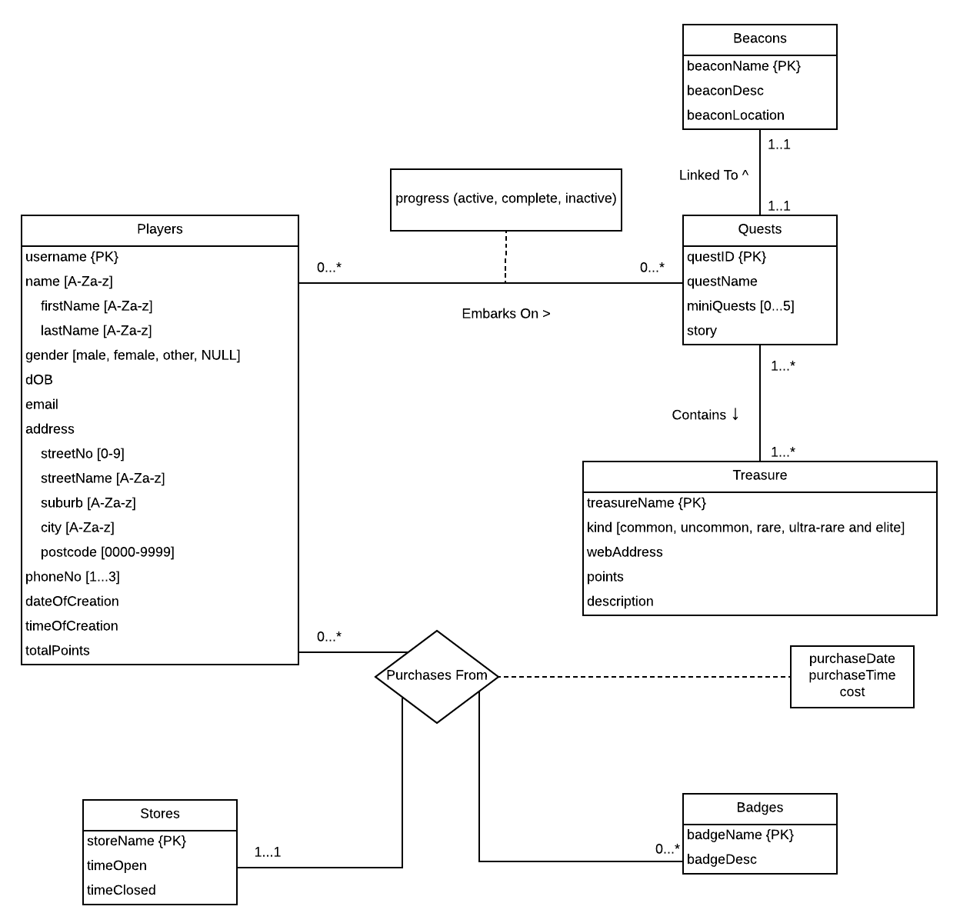

**Assumptions:**

* All quests contain at least one treasure.
* All treasure can be found in at least one quest, and may be found in more than one quest.
* All badges are purchased from a store.
* All treasures have a name that is distinct from other treasures.
* All store’s names are distinct from one another.
* All badges have a name that is distinct from other badges.
* A player can play multiple quests without having to finish them first.
* A player can only purchase from one store at a time.
* There is only one beacon to a quest.
* There is only one quest to a beacon.
* Beacons may have descriptions of themselves.

# Task 2 (Relational Model of Treasure Hunters with Justification)

**Initial sub-ERM Entities and Attributes:**

PLAYERS (username, firstName, lastName, gender, dOB, email, streetNo, streetName, suburb, city, postcode, phoneNo, dateOfCreation, timeOfCreation, totalPoints)

QUESTS (questID, questName, story, miniQuests)

TREASURE (treasureName, kind, webAddress, points, description)

BEACONS (beaconName, beaconDesc, beaconLocation)

UNKNOWN (progress)

**Justification of Derived Relations:**

PLAYERS and TREASURE are largely identical to its ERM representation.

QUESTS was derived by combining the entities QUESTS and BEACONS from the ERM, due to their mandatory 1.1 relationship. The beacon was chosen to be the attribute because QUESTS was the stronger, more independent, parent entity of the two.

MINIQUESTS was derived by being a multi-valued attribute of the entity QUESTS. PHONENUMBERS was derived by being a multi-valued attribute of the entity PLAYERS.

QUESTPROGRESS was derived from the attribute that was part of the relationship between the PLAYERS and QUESTS entities. Since the relationship attribute is weak and has no primary key, the two primary keys of the two entities in question became primary keys to QUESTPROGRESS.

**Relational Model:** Note: Underlined attributes are primary keys.

PLAYERS (username, firstName, lastName, gender, dOB, email, streetNo, streetName, postcode, suburb, city dateOfCreation, timeOfCreation, totalPoints)

QUESTS (questID, questName, story, beaconName, beaconDesc, beaconLocation)

TREASURE (treasureName, kind, webAddress, points, description)

MINIQUESTS (miniQuestName, questID)

PHONENUMBERS (phoneNo, username)

QUESTPROGRESS (progress, questID, username)

**Foreign Keys:**

* MINIQUESTS (questID) is dependent on QUESTS (questID).
* PHONENUMBERS (username) is dependent on PLAYERS (username).
* QUESTPROGRESS (questID) is dependent on QUESTS (questID).
* QUESTPROGRESS (username) is dependent on PLAYERS (username).

**Other Constraints:**

* PLAYERS (firstName, lastName, streetName, suburb, city) can only contain letters.
* PLAYERS (gender) must be male, female, other, or not given (NULL).
* PLAYERS (postcode) must be a four digit number.
* TREASURE (kind) can only be common, uncommon, rare, ultra-rare, or elite.
* QUESTPROGRESS (progress) must be active, inactive, or complete.

# Task 3 (Sample Data)

Note: Underlined attributes are primary keys.

## MINIQUESTS

|  |  |
| --- | --- |
| miniQuestName | questID |
| King In The North | q169 |
| King In The North | q054 |
| A True Jedi | q054 |
| Set Phasers On Stun | q003 |

Delete operation that would work: Deleting the following tuple will not raise any errors.

|  |  |
| --- | --- |
| King In The North | q169 |

Update operation that would work: Updating the following tuple will not raise any errors.

From:

|  |  |
| --- | --- |
| A True Jedi | q054 |

To:

|  |  |
| --- | --- |
| A True Jedi | q090 |

Update operation that would not work: Updating the following tuple would violate a key constraint (identical tuples).

From:

|  |  |
| --- | --- |
| A True Jedi | q054 |

To:

|  |  |
| --- | --- |
| King In The North | q054 |

Insert operation that would not work: Inserting the following tuple would violate an entity integrity constraint.

|  |  |
| --- | --- |
| Set Phasers On Stun | NULL |

## PHONENUMBERS

|  |  |
| --- | --- |
| username | phoneNumbers |
| BigBoi113 | 0999 999 998 |
| BigBoi113 | 0999 999 997 |
| BigBoi113 | 0999 999 996 |
| sh0eOnFoot | 0999 999 997 |

Delete operation that would work: Deleting the following tuple will not raise any errors.

|  |  |
| --- | --- |
| BigBoi113 | 0999 999 996 |

Update operation that would work: Updating the following tuple will not raise any errors.

From:

|  |  |
| --- | --- |
| sh0eOnFoot | 0999 999 997 |

To:

|  |  |
| --- | --- |
| sh0eOnFoot | 0555 555 557 |

Update operation that would not work: Updating the following tuple would violate a key constraint (identical tuples).

From:

|  |  |
| --- | --- |
| BigBoi113 | 0999 999 996 |

To:

|  |  |
| --- | --- |
| BigBoi113 | 0999 999 997 |

Insert operation that would not work: Inserting the following tuple would violate an entity integrity constraint.

|  |  |
| --- | --- |
| theCh0sen1 | NULL |

## QUESTPROGRESS

|  |  |  |
| --- | --- | --- |
| username | questID | progress |
| BigBoi113 | q169 | complete |
| BigBoi113 | q420 | active |
| sh0eOnFoot | q001 | inactive |
| theCh0sen1 | q169 | complete |

Delete operation that would work: Deleting the following tuple will not raise any errors.

|  |  |  |
| --- | --- | --- |
| sh0eOnFoot | q001 | inactive |

Update operation that would work: Updating the following tuple will not raise any errors.

From:

|  |  |  |
| --- | --- | --- |
| sh0eOnFoot | q001 | inactive |

To:

|  |  |  |
| --- | --- | --- |
| sh0eOnFoot | q001 | active |

Update operation that would not work: Updating the following tuple would violate a domain constraint.

From:

|  |  |  |
| --- | --- | --- |
| sh0eOnFoot | q001 | inactive |

To:

|  |  |  |
| --- | --- | --- |
| sh0eOnFoot | q001 | yes |

Insert operation that would not work: Inserting the following tuple would violate a referential integrity constraint, if quest “q999” didn’t exist.

|  |  |  |
| --- | --- | --- |
| BigBoi113 | q999 | inactive |

## TREASURE

|  |  |  |  |  |
| --- | --- | --- | --- | --- |
| treasureName | kind | webAddress | points | description |
| The Magic Conch | common | https://www.youtube.com/watch?v=lXMskKTw3Bc | 5000 | A treasure that can be found |
| The Red Jewel | common | https://www.youtube.com/watch?v=lXMskKTw3Bc | 3.7 | A treasure that can be found |
| Ferrari | ultra-rare | https://www.youtube.com/watch?v=lXMskKTw3Bc | 40000 | A treasure that can be found |
| The Holy Hand Grenade | elite | https://www.youtube.com/watch?v=lXMskKTw3Bc | 10000000 | A treasure that can be found |

Delete operation that would work: Deleting the following tuple will not raise any errors.

|  |  |  |  |  |
| --- | --- | --- | --- | --- |
| The Magic Conch | common | https://www.youtube.com/watch?v=lXMskKTw3Bc | 5000 | A treasure that can be found |

Update operation that would work: Updating the following tuple will not raise any errors.

From:

|  |  |  |  |  |
| --- | --- | --- | --- | --- |
| The Magic Conch | common | https://www.youtube.com/watch?v=lXMskKTw3Bc | 5000 | A treasure that can be found |

To:

|  |  |  |  |  |
| --- | --- | --- | --- | --- |
| The Magic Conch | common | https://www.youtube.com/watch?v=lXMskKTw3Bc | 50,000 | A treasure that cannot be found |

Update operation that would not work: Updating the following tuple would violate an entity integrity constraint.

From:

|  |  |  |  |  |
| --- | --- | --- | --- | --- |
| The Magic Conch | common | https://www.youtube.com/watch?v=lXMskKTw3Bc | 5000 | A treasure that can be found |

To:

|  |  |  |  |  |
| --- | --- | --- | --- | --- |
| NULL | common | https://www.youtube.com/watch?v=lXMskKTw3Bc | 5000 | A treasure that can be found |

Insert operation that would not work: Inserting the following tuple would violate a key integrity constraint (already a “Holy Hand Grenade” named treasure).

|  |  |  |  |  |
| --- | --- | --- | --- | --- |
| The Holy Hand Grenade | ultra-rare | https://www.youtube.com/watch?v=lXMskKTw3Bc | 0 | A treasure that can be stumbled upon |

## QUESTS

|  |  |  |  |  |  |
| --- | --- | --- | --- | --- | --- |
| questID | questName | story | beaconName | beaconDesc | beaconLocation |
| q169 | The Search For The Beacon | A brief description of the quest. | Beacon 1 | A brief description of the beacon. | 40.3399° N, 127.5101° E |
| q420 | The Quest For A Thing | A brief description of the quest. | Beacon 2 | A better description of the beacon. | 40.3399° N, 127.5102° E |
| q001 | Sample Quest Name | A brief description of the quest. | Beacon 3 | The best description of the beacon. | 40.3399° N, 127.5103° E |
| q667 | The Finding Of The Missing Story | Story not found. | Beacon 4 | NULL | 40.3399° N, 127.5104° E |

Delete operation that would work: Deleting the following tuple will not raise any errors.

|  |  |  |  |  |  |
| --- | --- | --- | --- | --- | --- |
| q001 | Sample Quest Name | A brief description of the quest. | Beacon 3 | The best description of the beacon. | 40.3399° N, 127.5103° E |

Update operation that would work: Updating the following tuple will not raise any errors.

From:

|  |  |  |  |  |  |
| --- | --- | --- | --- | --- | --- |
| q001 | Sample Quest Name | A brief description of the quest. | Beacon 3 | The best description of the beacon. | 40.3399° N, 127.5103° E |

To:

|  |  |  |  |  |  |
| --- | --- | --- | --- | --- | --- |
| q001 | 20,000 leagues under the brisbane river | An australian jules verne adventure | Finding Nemo DVD | The DVD of the movie Finding Nemo | 40.3399° N, 127.5103° E |

Update operation that would not work: Updating the following tuple would violate an entity integrity constraint.

From:

|  |  |  |  |  |  |
| --- | --- | --- | --- | --- | --- |
| q169 | The Search For The Beacon | A brief description of the quest. | Beacon 1 | A brief description of the beacon. | 40.3399° N, 127.5101° E |

To:

|  |  |  |  |  |  |
| --- | --- | --- | --- | --- | --- |
| NULL | The Search For The Beacon | A brief description of the quest. | Beacon 1 | A brief description of the beacon. | 40.3399° N, 127.5101° E |

Insert operation that would not work: Inserting the following tuple would violate a key integrity constraint (q667 already exists).

|  |  |  |  |  |  |
| --- | --- | --- | --- | --- | --- |
| q667 | The Finding Of The Found Story | Story already found. | Beacon 667 | NULL | 40.3399° N, 127.5104° E |

PLAYERS

|  |  |  |  |  |  |  |  |  |  |  |  |  |  |
| --- | --- | --- | --- | --- | --- | --- | --- | --- | --- | --- | --- | --- | --- |
| username | firstName | lastName | gender | dOB | email | streetNo | streetName | postcode | suburb | city | dateOfCreation | timeOfCreation | totalPoints |
| BigBoi113 | David | Jones | male | 01/01/1970 | d@j.com.au | 1 | Man St | 4022 | Rothwell | Redcliffe | 02/02/2001 | 0000 | 123,456 |
| sh0eOnFoot | John | Doe | female | 11/11/2011 | j@d.com.au | 2 | Man St | 4022 | Rothwell | Redcliffe | 02/09/2017 | 2359 | 3 |
| theCh0sen1 | Michael | McMillian | male | 08/07/2006 | m@m.com.au | 3 | Man St | 4010 | Albion | Brisbane | 02/02/2001 | 0600 | 41,968 |
| xXtentation | Yvette | Evans | NULL | 05/12/1849 | y@e.com.au | 2 | Desert Ave | 4000 | CBD | Brisbane | 28/02/2015 | 1123 | 68,689 |

Delete operation that would work: Deleting the following tuple will not raise any errors.

|  |  |  |  |  |  |  |  |  |  |  |  |  |  |
| --- | --- | --- | --- | --- | --- | --- | --- | --- | --- | --- | --- | --- | --- |
| theCh0sen1 | Michael | McMillian | male | 08/07/2006 | m@m.com.au | 3 | Man St | 4010 | Albion | Brisbane | 02/02/2001 | 0600 | 41,968 |

Update operation that would work: Updating the following tuple will not raise any errors.

From:

|  |  |  |  |  |  |  |  |  |  |  |  |  |  |
| --- | --- | --- | --- | --- | --- | --- | --- | --- | --- | --- | --- | --- | --- |
| sh0eOnFoot | John | Doe | female | 11/11/2011 | j@d.com.au | 2 | Man St | 4022 | Rothwell | Redcliffe | 02/09/2017 | 2359 | 3 |

To (totalPoints updated):

|  |  |  |  |  |  |  |  |  |  |  |  |  |  |
| --- | --- | --- | --- | --- | --- | --- | --- | --- | --- | --- | --- | --- | --- |
| sh0eOnFoot | John | Doe | female | 11/11/2011 | j@d.com.au | 2 | Man St | 4022 | Rothwell | Redcliffe | 02/09/2017 | 2359 | 4 |

Update operation that would not work: Updating the following tuple would violate an entity integrity constraint.

From:

|  |  |  |  |  |  |  |  |  |  |  |  |  |  |
| --- | --- | --- | --- | --- | --- | --- | --- | --- | --- | --- | --- | --- | --- |
| BigBoi113 | David | Jones | male | 01/01/1970 | d@j.com.au | 1 | Man St | 4022 | Rothwell | Redcliffe | 02/02/2001 | 0000 | 123,456 |

To:

|  |  |  |  |  |  |  |  |  |  |  |  |  |  |
| --- | --- | --- | --- | --- | --- | --- | --- | --- | --- | --- | --- | --- | --- |
| NULL | David | Jones | male | 01/01/1970 | d@j.com.au | 1 | Man St | 4022 | Rothwell | Redcliffe | 02/02/2001 | 0000 | 123,456 |

Insert operation that would not work: Inserting the following tuple would violate a key constraint, xXtentation already exists.

|  |  |  |  |  |  |  |  |  |  |  |  |  |  |
| --- | --- | --- | --- | --- | --- | --- | --- | --- | --- | --- | --- | --- | --- |
| xXtentation | Babe | Maria | other | 01/09/2017 | b@m.com.au | 98 | Oasis Rd | 4555 | Hunchy | Nambour | 03/09/2017 | 2311 | 42,421 |

# Task 4 (Normal Forms of Example Relations)

The “Player” relation is a 0NF, because it does not satisfy the 1NF requirement of having only one value per relation cell, the attribute “Quests” has multiple values in its column.

The “Treasure” relation is a 1NF, because while it only has one value per relation cell, not all non-primary keys are fully-functionally dependant on the primary keys. The attributes “Quest Name” and “Quest Beacon” are dependent on primary key “Quest_id”, but not dependant on primary key “Name”, having only a partial dependency for (“Name”, “Quest_id”).

The “Address” relation is a 2NF, because while it only has one value per relation cell, and all non-primary keys are fully-functionally dependant on the primary key, some are dependant transitively. The column “city” is dependent on the primary key “Id” transitively through “postcode”, because a city can be determined through postcode, not street name or street number. Street number, street name, and postcode cannot be determined from each other, and therefore aren’t in a transitive dependancy of any sort.